1. **Covariance** – its definition is in the name itself. For two variables; covariance is a measure of how the variables vary wrt to each other linearly.

**Correlation**: it quantifies the linear relationship between two variables.

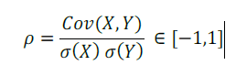

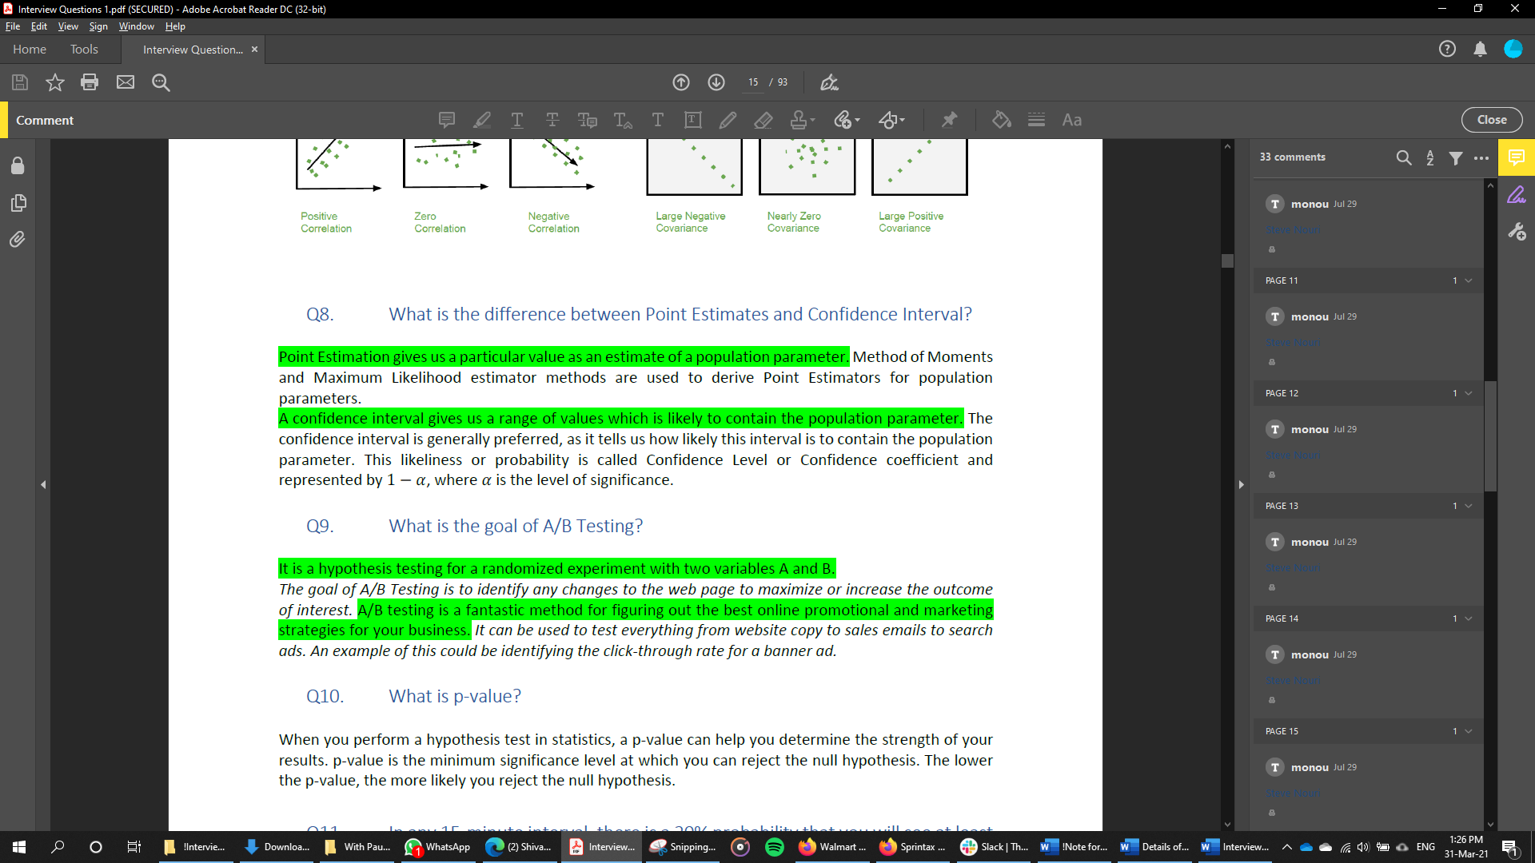

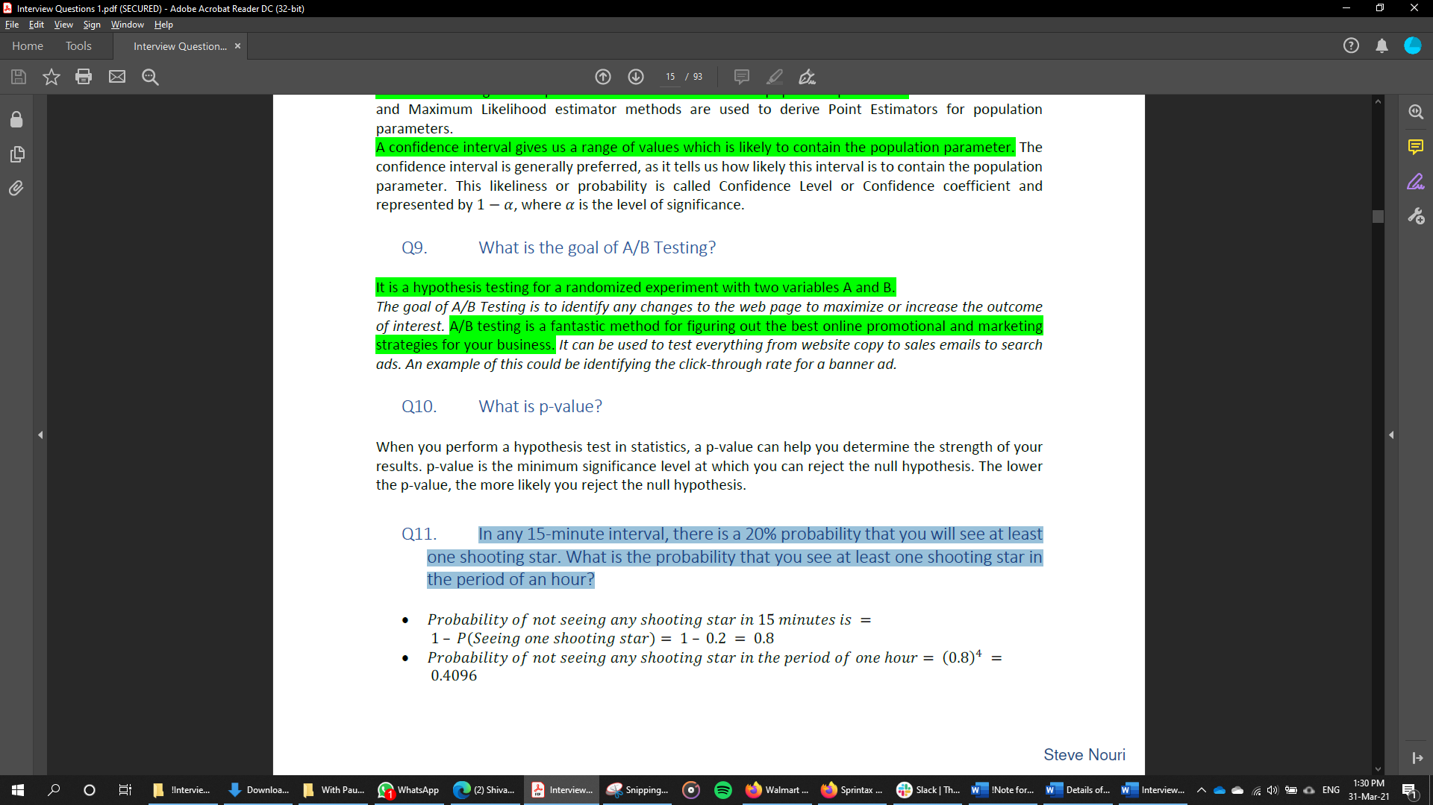

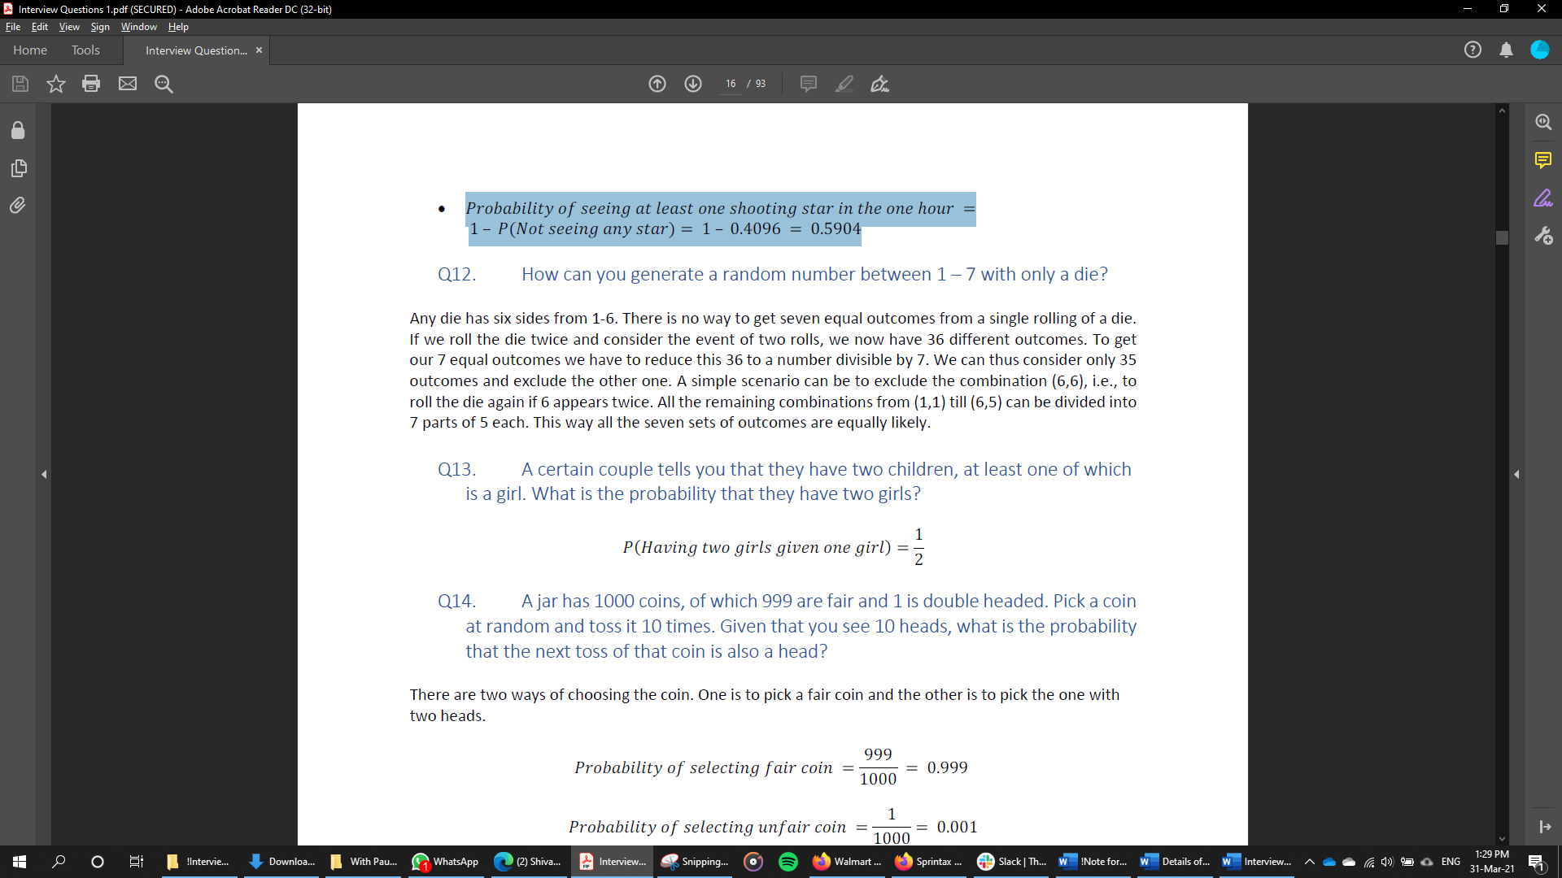

1. What is Resampling?

Resampling is done to get more accurate estimate of a population parameter. It is like cross validation.

1. What Cross validation technique would you use for a time series model?

**Instead of using k-fold cross-validation, you should be aware of the fact that a time series is not randomly distributed data — It is inherently ordered by chronological order.**

In case of time series data, you should use techniques like **forward chaining (Window sliding)** — Where you will be model on past data then look at forward-facing data.

fold 1: training[1], test[2]

fold 2: training[1 2], test[3]

fold 3: training[1 2 3], test[4]

fold 4: training[1 2 3 4], test[5]

